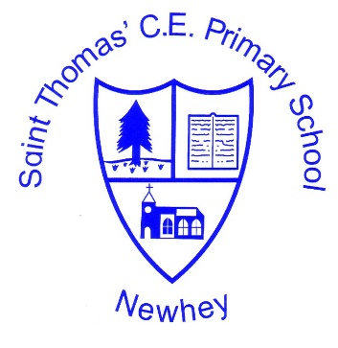
The Little School with the Big Heart
‘With God All Things are Possible’ Matthew 19:26

Below are the core vocabulary lists for PE:
They give examples of the subject specific vocabulary that children will use and become familiar with during each key stage, reflecting their increasing knowledge, breadth and depth of experiences and can be used across a range of topic areas. They are not intended to be used to test pupils but give an indication of the language and terms used by staff in lessons and across units of learning to broaden vocabulary and understanding.
EYFS | Years 1 & 2 | Years 3 & 4 | Years 5 & 6
Space, looking up, stretch/ muscle, partner, pairs ,run, walk, balance, throw, catch, hit, ball, cone, net, bean bag, jump, hop, carry, follow, lead, copy, sports, games, rules, move, forwards, backwards, equipment, speed, directions, bounce, push, pull, roll | Games  Throw, roll, underarm, hit, move, move, safely, kick, tactics, decide, rules  Gymnastics  Curl, tense, stretch, relax, control, travel, balance, copy, sequence, improve, plan, and perform, feedback, hold and independent  Dance  Move, copy perform, create, rhythm, control co-ordination, linking mood or feeling | Games  Throw, catch, control, awareness of space, support, opposition, strike and field, accuracy, rules, possession, adapt tactic  Gymnastics  Adapt sequences, apparatus, criteria, strength, suppleness, performance, compare and contrast, sequences, stamina, improve.  Dance  Changing speed and direction, share and create phrases, plan, repeat, remember and perform phrases, communicate  Athletics  Change speed and direction, underarm, overarm, throwing, technique, distance sprint, accuracy, personal best  Outdoor and Adventurous  Follow, route, appropriate equipment, safely, familiar context, manage risks/problems  Swimming  Swim, unaided, basic stroke, movements, co-ordinate, breathing, surface | Games  Possession, forehand, backhand, field, tactics, defending, attacking, techniques, pass, dribble and shoot. Striking, implement, rules, umpire and strategy.  Gymnastics  Complex, extended sequences, combine, perform, consistency audience, link, vault, spring  Dance  Compose, creative perform, accompaniment, demonstrate, clarity, fluency, accuracy and consistency. Style, interpret, precise and posture  Athletics  Control, accuracy, techniques, combine, distance, compete, improve personal best, stamina  Outdoor and Adventures  Location, compass, navigate , overcome problems, plan, route, safety, danger, leadership

