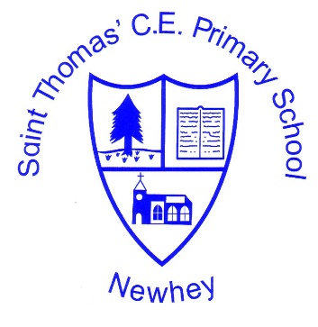
Subject Overview – Physical Education

VISION
At St Thomas’ we endeavour to support and promote excellence through PE whilst ensuring healthy lifestyles and the opportunity for all children to engage in regular competitive sport and activities, therefore developing competency across a broad range of physical activities. St Thomas’ nurtures and encourages all children to realise their personal best and to fulfil their potential in the academic, sporting and performing opportunities provided in and out of school. By promoting PE at our school, we aim to develop an enjoyment of PE for all children; enable children to develop physically, cognitively and socially; and develop physical skills, habits and interests that will promote a healthy lifestyle.
COVERAGE – At a glance to be used in conjunction with year group medium term plans
Class | Autumn 1 | Autumn 2 | Spring 1 | Spring 2 | Summer 1 | Summer 2
Class 1  One Goal takes both sessions | Fundamentals  Superheroes | Fundamentals  Fairy Tales | Fundamentals  Gymnastics  (Inside) | Fundamentals  Exploring | Fundamentals  Seasons | Fundamentals  Transports
Class 2 | Fundamentals  Balance, jumping etc | Fundamentals  Balance, jumping | Fundamentals  Circuits(Inside) | Fundamentals  Circuits  (Inside) | Fundamentals | Fundamentals
Class Teacher | Dance  seasons | Christmas performance - dance | Year 1 Gymnastics | Year 2 Gymnastics | Dance Outside Cross Curricular | Athletics  Get ready for sports day
Class 3 | Dodgeball | Rugby | Basketball | hockey | Cricket/  Rounders | Athletics
Class Teacher | Gymnastics Year 2 | Christmas performance - dance | Year 3 Gymnastics | Dance Outside Cross Curricular | Dance Outdoors | Athletics  Get ready for sports day
Class 4 | Dodgeball | Rugby | Basketball | hockey | Cricket/  Rounders | Athletics
Class Teacher | Dance  Ballet | Christmas performance - dance | Gymnastics | Swimming | Swimming | Swimming
Class 5 | Dodgeball | Rugby | Basketball | hockey | Cricket/  Rounders | Athletics
Class Teacher | Dance  Street dance | Gymnastics  Year 5 | Gymnastics Year 6 | HITT Class | Dance  Outside | Athletics and Performance dance for show

